EXPERIMENT NO. 02
AIM: Simulation of non-inverting amplifier circuit using PSPICE
PROBLEM STATEMENT: Design non inverting op – amp and measure the gain and plot input and output waveforms.
SOFTWARE REQUIRED: PSPICE software
THEORY:
In this configuration of Op-amp the input signal is directly fed to the non-inverting terminal resulting in a positive gain and output voltage in phase with input as compared to inverting Op-amp where the gain is negative and output voltage is out of phase with input , and to stabilize the circuit a negative feedback is applied through a resistor(Rf) and the inverting terminal is grounded with input resistor(R2).This inverting Op-Amp like layout the at inverting terminal creates a virtual ground at the summing point make the Rf and R2 a potential divider across inverting terminal, Hence determines the gain of the circuit.

The gain is calculated by:
$$A_{cl}=1+\frac{R_{F}}{R_{2}}$$

CIRCUIT DIAGRAM:

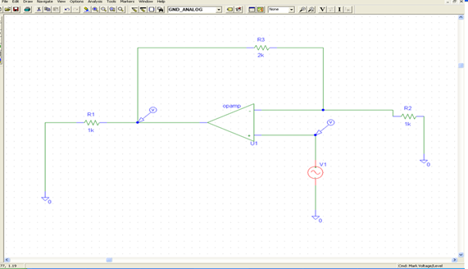
FIGURE 1: Schematic of NON-INVERTING AMPLIFIER Circuit
PROCEDURE:
- Design NON-INVERTING AMPLIFIER as per circuit diagram in Pspice Schematic.
- Use Current Marker for Input and Output waveform.
- Select Transient Analysis as per fig. no 2.
- Simulate the circuit and study the Input/output waveforms.
- Most commonly error occurred during simulation is Net list/ERC error, it is due to incomplete connections, you will observe this error as Floating point error, open Pspice message viewer double click on the error line, then it will revert back to schematic window and mouse cursor indicate the location of error in the schematic.
- Once the schematic is error free, OrCADPspice A/D Demo window will open and following waveform is observed.
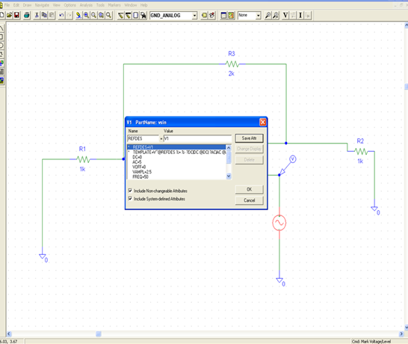
FIGURE 2(a): Setup Analysis

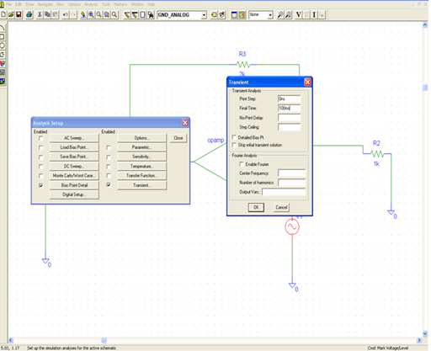
FIGURE 2(b): Setup Analysis
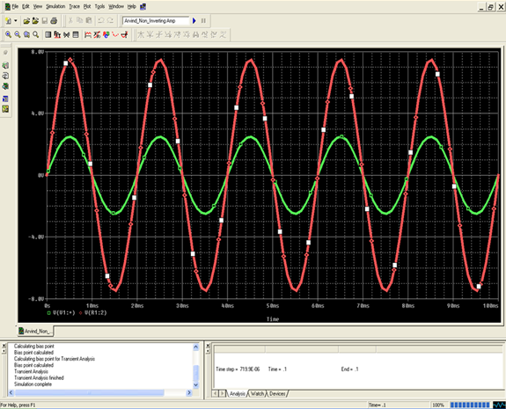
FIGURE 3: Output of NON-INVERTING AMPLIFIER Circuit

RESULT:Non-inverting amplifier Circuit is studied and gets the output using PSPICE Software and calculate the gain.

VIVA VOCE:

- What do you mean by non-inverting amplifier?
- What is the difference between inverting and non-inverting input?
- Why feedback is used in op amp?
- What is operational amplifier and its types?
- What is the principle of amplifier?
- Why feedback is used in op amp?

